 CHEMICAL ENGINEERING TRANSACTIONS  VOL. xxx, 2026 | A publication of  
The Italian Association
of Chemical Engineering
Online at www.cetjournal.it

Guest Editors: Valerio Cozzani, Bruno Fabiano, Genserik Reniers
Copyright © 2026, AIDIC Servizi S.r.l.
ISBN 979-12-81206-xx-x; ISSN 2283-9216

Casual or Causal? The Lightning-Triggered NaTech Accident at the Supertanker Base of Matanzas, Cuba
David J. Castro Rodriguezª*, Julio A. Dueñas Santana^{b}, Antonello A. Barresiª, Micaela Demichelaª
ªDepartment of Applied Science and Technology, Politecnico di Torino, Corso Duca degli Abruzzi 24, 10129 Torino, Italy
^{b} VSB – Technical University of Ostrava, Faculty of Safety Engineering, Centre of Excellence for Safety Research, 17. listopadu 2172/15, 708 00 Ostrava, Czech Republic.
david.castro@polito.it

Lightning strikes are a significant natural hazard for process plants, particularly in storage and handling facilities, where they often lead to large-scale loss of containment of dangerous substances. Because lightning is itself an ignition source, the probability that flammable materials released after a lightning strike will ignite is much higher than in conventional loss-of-containment scenarios. This often leads to major fires that can trigger cascading effects on nearby units. Therefore, high-capacity storage tanks located in tank farms or industrial clusters constitute highly vulnerable assets, since lightning strikes may lead to severe consequences for this critical equipment, with potentially serious impacts on the infrastructure, the environment, and nearby communities. This paper critically reflects on the NaTech accident at the Supertanker Base of Matanzas, where a catastrophic fire broke out in four of the eight tanks of the largest crude oil storage farm in Cuba. A structured causal analysis of the accident dynamics was conducted, stressing both technological and systemic factors, drawing on recent insights from the emerging literature on NaTech events in the process industry. The methodological approach adopted, together with the lessons learned from this catastrophic event, contributes to a deeper understanding of the complex dynamics of lightning-triggered NaTech scenarios, supporting risk-reduction decision-making and strengthening resilience in similar contexts.
Keywords: major fire, lightning strike, NaTech, storage tank, technological scenarios.
  - Introduction
NaTech events can be regarded as a specific multi-risk phenomenon in which at least an external natural hazard triggers a technological scenario involving the release of dangerous substances resulting in large-scale disasters with severe consequences for human safety, the environment, and surrounding infrastructure (Castro Rodriguez et al., 2025a). They may occur wherever industrial facilities storing or handling hazardous materials are in areas exposed to natural hazards (Necci and Krausmann, 2022). NaTech events exhibit unique features that differentiate them from conventional technological accidents, including potential cascading effects, which complicate emergency response efforts (Ricci et al., 2024). Limited awareness or preparedness can significantly reduce the effectiveness of strategies to cope with NaTech events (Necci and Krausmann, 2022).
Among the natural hazards, the lightning-triggered technological scenarios pose a critical trade-off for the process industry, combining relatively frequent occurrence with catastrophic consequences (Castro Rodriguez et al., 2024). The previous statement is supported by early evidence analyzing the relevance of atmospheric triggers in 232 accident records, with lightning representing 33% of the identified natural initiating factors (Rasmussen, 1995). Quantitative evidence of the magnitude of lightning-induced releases has been given by Renni et al. (2010), who shown that lightning-triggered accidents resulted in off-site loss of containment of dangerous substances exceeding 1000 kg in 38% of the 335 analyzed events. Recent large-scale datasets (Ricci et al., 2021) confirm lightning as a significant NaTech trigger in the process industry (11.3% of 9,100 events), while particular attention should be given to its susceptibility to climate change impacts, due to the expected increase in the frequency and severity of meteorological events (Caratozzolo et al., 2022).
The severity of lightning-triggered accidents is driven by their high ignition probability, with an 82% likelihood for flammable substances, leading to frequent major fires (Krausmann et al., 2011). Mandal and Agarwal (2023) also identified lightning as the heat source in approximately one-third of exterior storage tank fires, confirming its relevance as a direct ignition mechanism in industrial environments. Lightning may affect chemical facilities through direct strikes, causing structural damage from intense thermal effects, or through indirect mechanisms such as induced sparks, electrical surges, and overvoltage, as well as disruptions to control, instrumentation, and auxiliary systems. These interactions can escalate if flammable vapors are present. Lightning-triggered fires may generate cascading effects across neighboring equipment, increasing the complexity of emergency response. Misuri et al. (2020) demonstrated that fires in storage tanks are a recurrent primary cause of domino escalation. The previous considerations suggest that, despite the long-standing recognition of lightning hazards, current protection systems and measures in storage farms might remain insufficient to fully mitigate the NaTech risk. This research performs a structured causal analysis around the catastrophic NaTech accident which occurred at the Matanzas Supertanker Base (Cuba) on August 5 of 2022, examining the event dynamics in relation to key technological and systemic contributing factors.
  - Matanzas NaTech Event and Causal Analysis Framework
This section consists of two parts: (i) an overall description of the lightning-triggered technological accident at the Matanzas Supertanker Base, a critical energy infrastructure in Cuba; and (ii) an outline of the methodological approach adopted to perform a structured causal analysis of this catastrophic NaTech event as a case study.
    - Lightning-triggered NaTech at the Supertanker Base of Matanzas, Cuba
The Matanzas Supertanker Terminal, located in the Port of Matanzas (Cuba) and operated by the national Fuel Commercializing Company (Empresa Comercializadora de Combustibles in Spanish), was commissioned in the late 1980s. The terminal comprises five deep-water berths designed to receive tankers of up to 180,000 deadweight tonnage, with a maximum draft of approximately 20 m.. With an overall storage capacity close to 800,000 m³, the site represents one of the largest national hubs for the handling and storage of multiple petroleum products and is therefore considered a critical component of Cuba energetic infrastructure. In 2012, major rehabilitation works were conducted to restore large-volume crude oil storage units and expand operational capacity. Several tanks were retrofitted with geodesic dome roofs, consisting of lightweight aluminium structural systems to mitigate hydrocarbon evaporation losses. The storage system included ten atmospheric tanks of 50,000 m³ each, eight of which are arranged in the northern tank farm with an inter-tank spacing of approximately 50 m. Additional process and storage units, including the crude supply base and a terminal dedicated to refined products, are located in the western sector of the industrial complex, where smaller-capacity tanks are installed (Figure 1).
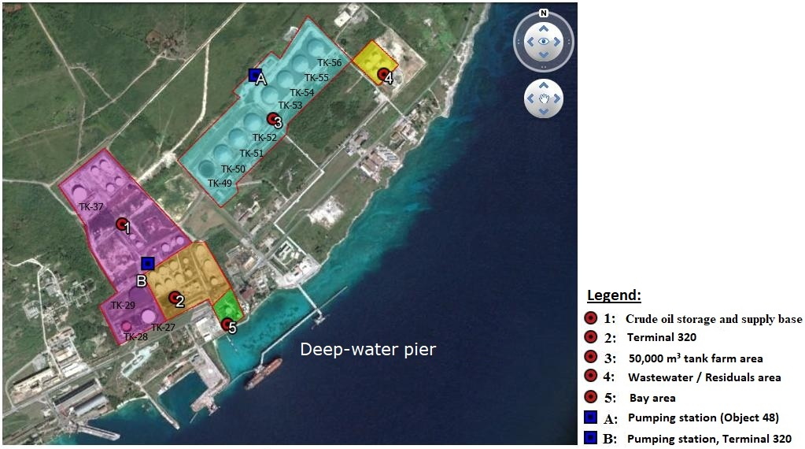
Figure 1: Matanzas Supertanker Base. Source: Modified from Cabrera-Estupiñán et al. (2016).
The initiating incident occurred on August 5 of 2022, approximately at 19:00, when lightning struck the geodesic dome roof of one of eight hydrocarbon tanks in the farm area igniting a fire (TK-52 in Figure 1). This tank contained approximately 26,000 m³ of fuel oil (approximately 50% of its capacity). By 5:00 a.m. on August 6, despite ongoing firefighting and cooling efforts, Tank 51 exploded, further escalating the incident. Several explosions occurred, including the boilover phenomenon—defined as the violent ejection of liquid hydrocarbons caused by the vaporization of water layers beneath the fuel during prolonged storage tank fires. These events led to tank rupture and structural failure. By August 8, a change in wind direction from the Northeast caused the fire to spread to tank 50 containing fuel oil. The flames subsequently reached tank 49 of crude oil, thereby substantially increasing the magnitude and consequences of the accident. The three additional affected tanks after the initiating event were all full, with a capacity of 50,000 m³. The resulting thermal radiation reached extreme intensities, severely impacting surrounding industrial areas. Thermal radiation intensities peaked at around 70 kW/m² within a radius of 500 meters after the initial fireball, considerably amplifying the severity of the incident. The firefighters, assisted by Mexican and Venezuelan reinforcements, also cooled tanks 53, 54, 55, and 56 and put out the fire after five days. The four tanks involved in the fire were destroyed and the inventory was totally lost. Consequently, a large amount of toxic black smoke persisted for approximately five days, substantially deteriorating regional air quality. Although the accident caused substantial operational and environmental impacts, its most severe effects were on the human and social dimension, which reached level 5 on the European industrial accident scale (where 6 represents the maximum severity). This led to 16 fatalities among firefighting personnel, 132 injuries, and the temporary evacuation of 4744 residents (BARPI, 2024). Figure 2 shows selected snapshots of the dynamics described.
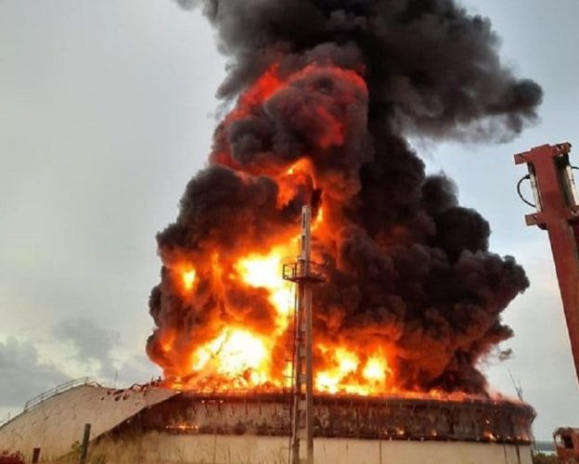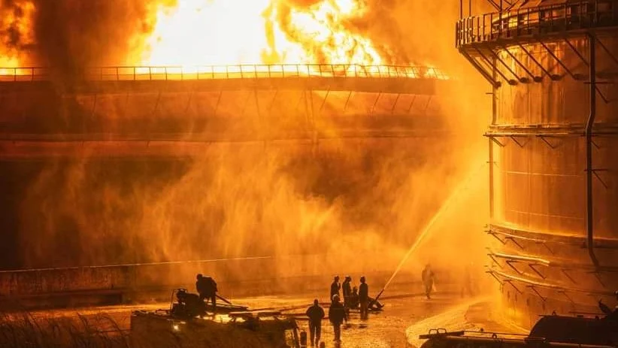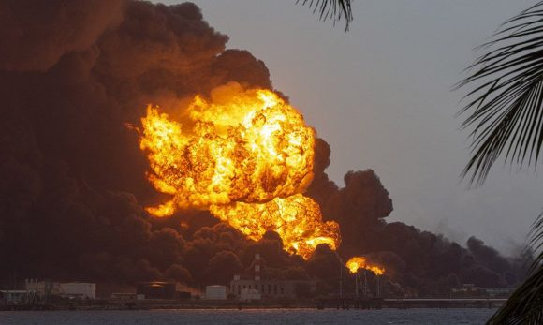
- b) c)
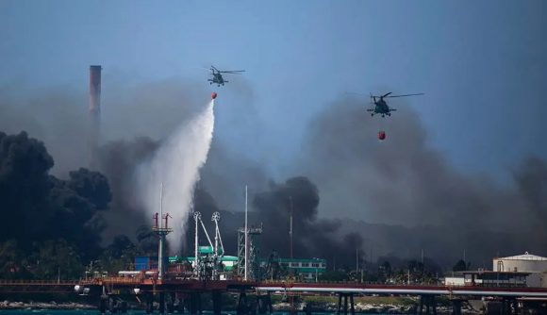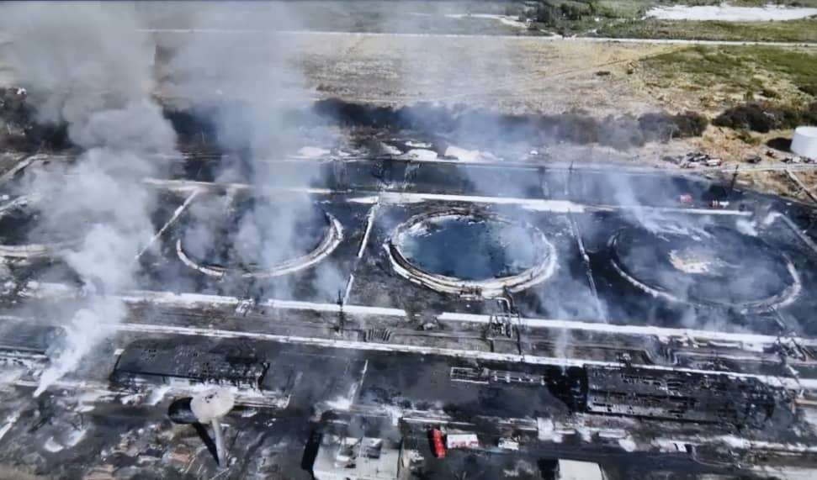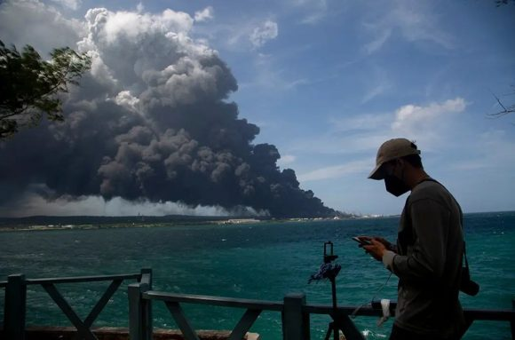
d) e) f)
Figure 2: Major fire at the Matanzas Supertanker Base: a) Fire in tank 52. Source: Portal Cubadebate. b) Firefighters cooling tank 51. Source: Gramma Newspaper. c) Third day of fire. Source: Portal Cubadebate. d) Aircraft fighting the fire. Source: Portal Cubadebate. e) Accident zone after five days. Source: The presidency of Cuba. f) Black smoke cloud above the Matanzas Supertanker Base. Source: Portal Cubadebate.
    - Fishbone diagram framework for structured causal analysis of NaTech events
The causal analysis was performed using an innovative fishbone diagram. The fishbone (or cause-and-effect) diagram, originally developed by Dr. Kaoru Ishikawa, is a structured tool for identifying outcomes and the variables that contribute to their occurrence. In this study, the fishbone diagram was adapted by structuring its main branches around the Awareness and Preparedness stages, aligned with the short-term coping capacities for resilient multi-risk NaTech management in industrial critical infrastructures (Castro Rodriguez et al., 2025b).
Second, the stratification method was applied to identify the principal potential causes by decomposing criticalities of the system within the awareness and the preparedness stages. On the one hand, functional and territorial critical vulnerabilities to lightning were stressed using criteria reported by Castro Rodriguez et al. (2024, 2025b), respectively. On the other hand, accident-related issues were identified based on applied research on storage tank failures by Chang and Lin (2006). Their work was used to link the most critical factors contributing to lightning-triggered escalation and propagation, consistently with the framework proposed by Sudha and Kalaiselvam (2026). In addition, the classification of preventive and mitigation barriers for NaTech scenarios in storage tanks developed by Mandal and Agarwal (2023) was adopted to reflect on the system's protective capacity to withstand lightning-triggered events. Finally, the criteria proposed by Khakzad (2023) were used to discuss firefighters thermal dose exposure during emergency response operations.
  - Structured Analysis of Vulnerabilities, Protective Capacity, and Emergency Response
This section analyses the fishbone diagram in Figure 3 for the NaTech accident described in subsection 2.1, following the structured framework in 2.2. Subsection 3.1 addresses location-based vulnerabilities, 3.2 examines technological vulnerabilities, 3.3 evaluates protective capacity, and 3.4 discusses emergency response.
Figure 3: Fishbone Diagram of lightning-triggered NaTech accident at the Matanzas Supertanker Base.
    - Location-based vulnerability to lightning at the Matanzas Supertanker Base
In Cuba, lightning frequency is estimated based on the average annual number of thunderstorm days, or keraunic level (T_{d}) (Álvarez-Escudero and Borrajero-Montejo, 2020). Specifically, Matanzas stands out as one of the provinces with the highest occurrence percentages, with isokeuranic values in the north-central strip ranging between 130 and 150 days/year and reaching their maximum activity in August. Taking the median value, the keraunic level of T_{d}=140 days/year, the density of lightning strikes to the ground (N_{g}) was determined using the estimation in Eq (1), according to Annex A of the Cuban national standard NC IEC 62305-2 (2009).
$N_{g}≈0.1∙T_{d}=0.1∙140=14 lightning/year⋅{km}^{2}$ (1)
N_{g} ≈ 14 strikes/year·km² exceeds the Ng > 8 threshold for very high atmospheric exposure (Krausmann et al., 2011), indicating extreme territorial vulnerability (typical of the Caribbean zones) and justifying maximum protection levels. Reinforcement is particularly critical during the spring and summer peaks, consistent with the 85%) of the seasonality patterns reflected by historical lightning-triggered NaTech records (Castro Rodriguez et al., 2024), and should be further emphasized in light of potential associated impacts of climate change. The occurrence of the Matanzas accident in August and prior nearby strike at the Antonio Guiteras thermoelectric plant at 3000 m of distance approximately, further confirm not only the seasonal pattern but also the systemic regional exposure, which should have served as a warning signal for operators and practitioners.
    - Functional-based vulnerability analysis of lightning at the Matanzas Supertanker Base
Historical evidence according to Castro Rodríguez et al. (2024) shows that ignition scenarios—fires, explosions, or combined events—account for 87% of classifiable cases, with fires representing approximately two-thirds of the total (64%). This distribution is fully consistent with the final scenario observed in the case study. Conditional analyses further indicate that a fire scenario is highly probable following a direct lightning strike to industrial units (S1), with P(Fire∣S1) = 0.55. When severe structural damage with total inventory release occurs (DS2), the probability increases significantly (P(Fire∣DS2) = 0.76). This combined pattern closely reflects the sequence observed in tank 52, where lightning strike, structural damage, and total inventory combustion followed a highly recurrent historical trajectory. Furthermore, regarding the analysis of the equipment involved—identified as the key functional variable in the vulnerability modeling—storage equipment exhibits the highest sensitivity to lightning among the eight industrial equipment classes, accounting for approximately 45% of the 127 classifiable historical records. Bayesian conditional modeling further indicates that the probability of storage equipment being impacted, given that the plant belongs to the “storage and warehousing” macro-sector, reaches 0.68, highlighting the intrinsic exposure of storage yards to lightning hazards. Moreover, the probability of a fire scenario given that storage equipment was struck is P(Fire∣Storage equipment) = 0.67. Overall, the Matanzas case reflects recurring NaTech patterns, highlighting systemic vulnerability rather than an isolated incident.
    - Protective capacity to withstand lightning-induced disruptions
Considering the territorial vulnerabilities discussed in Section 3.1, then, lightning protection levels (LPL) I–II are typically required. However, as highlighted in Section 3.2, facilities involving major infrastructure with hazardous inventories require the most stringent protection levels in critical areas, in accordance with NC IEC 62305-3 (2016). A conventional Lightning Protection System (LPS) comprises air-termination systems (e.g., Franklin rods, early streamer emission devices, or meshed conductors), down conductors, grounding systems, surge protective devices (SPD), and equipotential bonding measures, which require periodic inspections. For ignition to occur, the lightning strike or its secondary effects must be coupled with a flammable mixture. In dome-roof storage tanks, air-termination systems are often installed above the dome structure. The aluminum dome itself may provide a Faraday cage effect, potentially acting as a secondary protective barrier, provided no flammable vapor–air mixture is present externally. Under ideal sealing conditions, the structural shell can therefore reduce the probability of direct ignition. Loss of tight sealing—due to maintenance operations, mechanical damage, or venting system malfunction—may create explosive atmospheres.
From a causal perspective, several technical failure mechanisms can be considered: i) degradation or discontinuity of the grounding system; ii) insufficient equipotential bonding; iii) compromised dome sealing due to maintenance activities leading to vapor exposition; and iv) indirect lightning current propagation through instrumentation or sensor cabling. Overall, in the absence of evidence of a single-point failure, the event is better understood as the outcome of interacting factors. This systemic perspective coherently aligns with the causal pathways identified in the ignition-source branch of the fishbone diagram.
From a barrier failure perspective, the active fire protection system (FPS) functioned as a mitigation barrier intended to limit thermal escalation following ignition. Its safety function comprised two coupled mechanisms: (i) structural cooling to prevent tank failure and domino effects and (ii) foam-based extinguishment to suppress combustion. The fishbone structure identifies a progressive degradation pathway within this barrier. At the root level, insufficient water storage capacity and limited pumping capacity constrained the system hydraulic reliability. Because pumping demand exceeded water accumulation rates, the system operated in intermittent cycles, leading to frequent shutdowns. These interruptions reduced cooling continuity, resulting in degraded thermal control capacity. Consequently, foam injection was delayed or could not be sustained, particularly in tank 52. In barrier theory terms, this does not represent an instantaneous failure but a capacity exceedance mechanism. It was recognized by the authorities that the FPS at the Supertanker base of Matanzas was validated for a bounded fire scenario (approximately three hours), whereas the analyzed event evolved into a prolonged, high-intensity exposure lasting several days. Additionally, the event evolved under multi-hazard interaction due to a change in the direction of wind, which contributed to fire intensification and flame tilting, thereby amplifying the escalation potential. Accordingly, the escalation is best understood as progressive barrier degradation and saturation under extreme demand, rather than a single mechanical failure.
    - Emergency response
Since 2013, Cuba has maintained a regulatory framework governing safety management in major hazard installations handling hazardous chemicals. Within the established legal framework, emergency response constitutes a component of system preparedness. However, given the absence of public access to the Safety Report, predefined emergency scenarios, intervention thresholds, and resource adequacy assumptions cannot be externally verified. Therefore, the evaluation of response effectiveness must rely on observed dynamics.
Considering the magnitude and rapid escalation of the accident, several corrective and adaptive measures were implemented, illustrating the system attempt to expand its operational capacity beyond initial internal resources. Despite the significant response efforts, the severity of the event revealed limitations in emergency response capacity, which functioned as a tertiary mitigation barrier after the degradation of technical protection systems. The loss of 16 firefighters’ life highlights the challenges faced by external responders confronting complex NaTech conditions. Notably, part of the brigade consisted of young conscripts (18–27 years old) performing mandatory military service, many of whom had limited prior firefighting experience and were mobilized under emergency circumstances. Quantitative estimation (~70 kW/m²) indicates critical exposure levels exceeding both human survivability and firefighter PPE protective envelopes within seconds. Probit analysis confirms that such flux levels correspond to near-certain fatality for short seconds of exposure durations, under idealized conditions, and substantially faster under combined radiation–convection–wind coupling, consistent with the criteria of Khakzad (2023). Therefore, the loss of personnel is consistent with exposure beyond human and equipment resilience limits rather than solely with tactical misjudgement.
  - Conclusions
This work reflects on the lightning-triggered NaTech accident at the Supertanker Base of Matanzas, Cuba, applying a novel analytical approach that embeds resilience-based stages, stratified vulnerability analysis, and barrier performance evaluation within a unified fishbone framework for multi-hazard causal assessment. The event is therefore interpreted not as a casual black swan or unlucky episode, but as a systemic resilience breakdown under compounded hazard stress, in which anticipation, absorptive capacity, mitigation performance, and emergency response margins were progressively exceeded. Although protective and response systems remained operational, they functioned beyond their design and human performance envelopes, resulting in catastrophic escalation. These integrated causalities offer actionable insights to enhance process facility resilience to NaTech events, especially under potential climate change impacts.
Acknowledgments
In memory of the victims and those who mourn their loss.
References
Álvarez-Escudero, L., Borrajero-Montejo, I., 2020, Actualización del mapa de niveles ceráunicos de Cuba [An Update of the keraunic map of Cuba] (In Spanish), Rev. Cubana Met., 26, 2, 1–7.
BARPI, 2024, The ARIA Database [WWW Document]. The French bureau for analysis of industrial risks and pollutions (BARPI), Report N° 59453-05/08/2022-CUBA-00-MATANZAS <aria.developpement-durable.gouv.fr/accident/59453_en/?lang=en> accessed 22.09.2024.
Cabrera Estupiñán, E., Alomá Barceló, A., Ramos Arzola, L.C., Zambrano Zambrano, C.M., Hydraulic simulation in the analysis of firefighting systems for the oil industry (in Spanish), XXVII Congreso Latinoamericano de Hidráulica, Lima, Perú, 28-30/09/2016, 1–14.
Caratozzolo, V., Misuri, A., Cozzani, V., A generalized equipment vulnerability model for the quantitative risk assessment of horizontal vessels involved in NaTech scenarios triggered by floods, Reliab. Eng. Syst. Saf. 223 (2022) 108504.
Castro Rodriguez, D.J., Mietkiewicz, J., Vitale, M., Baldissone, G., Demichela, M., Barresi, A.A., 2024, NaTech triggered by lightning: Novel insights from past events in the process industry. Heliyon 10, e31610.
Castro Rodriguez, D.J., Barresi, A.A., Demichela, M., 2025a, Multi-risk NaTech vulnerability indicator: A step further, J. Loss Prev. Process Ind., 95, 105588, 1–14.
Castro Rodriguez, D.J., Barresi, A.A., Demichela, M., 2025b. Resilience-based framework for enhancing NaTech risk management in industrial critical infrastructures, Environ Syst. Decis., 45:63.
Chang, J. I., Ling, C., 2006, A study of storage tank accidents, J. Loss Prev. Process Ind., 19 (1), 51–59.
Khakzad, N., 2023, Multi-objective optimization of firefighting strategies in process plants. Chem. Eng. Trans., 104, 175–180.
Krausmann, E., Cozzani, V., Salzano, E., Renni, E., 2011, Industrial accidents triggered by natural hazards: an emerging risk issue, Nat. Hazards Earth Syst. Sci., 11, 921–929.
Mandal, C.S., Agarwal, M., 2024, Natech risk assessment for crude oil storage tanks using fish bone diagram, Materials Today: Proc., 99, 170–176.
Misuri, A., Antonioni, G., Cozzani, V., 2020, Quantitative risk assessment of domino effect in NaTech scenarios triggered by lightning. J. Loss Prev. Process Ind. 64, 104095.
NC IEC 62305-2: 2009, Protection against lightning. Part 2: Risk management (in Spanish. National Standardization Office, La Habana, Cuba.
NC IEC 62305-3: 2016, Protection against lightning. Part 3: Physical damage to structures and human risk (IEC 62305-3: 2010, IDT) (in Spanish), National Standardization Office, La Habana, Cuba.
Necci, A., Krausmann, E., 2022, NaTech risk management—Guidance for operators of hazardous industrial sites and for national authorities (JRC129450 No. EUR 31122 EN), Publications Office of the European Union, Luxembourg, 1–50.
Rasmussen K., 1995, Natural events and accidents with hazardous materials, J. Hazard. Mater., 40, 43–54.
Renni E., Krausmann E., Cozzani V., 2010, Industrial accidents triggered by lightning, J. Hazard. Mater., 184.
Ricci, F., Casson Moreno, V., Cozzani, V., 2021, A comprehensive analysis of the occurrence of NaTech events in the process industry, Process Saf. Environ. Prot., 147, 703–713.
Ricci, F., Yang, M., Reniers, G., Cozzani, V., 2024, Emergency response in cascading scenarios triggered by natural events, Reliab. Eng. Syst. Saf., 243, 109820.
Sudha S., Kalaiselvam S., 2026, NaTech-specific Inherent Safety Index (NISI): A quantitative framework for evaluating safety performance during extreme weather and geophysical hazards in hazardous industrial clusters, Reliab. Eng. Syst. Saf., 268, 111965.

